EJ 3.2.1 SQ How to… Day to Day Xero

Purpose of this SQ How To: To show the day to day checks that need to be completed in Xero

Owner: Admin
Applicable to: Admin
Of interest to: Sales and Account Managers
Customers: All
Timescales: Daily

Introduction
This document will go through a guide of the processes in Xero that need to be completed daily to keep the accounts department running smoothly.
Sending out repeating invoices
Daily there can be anywhere from 1 – 20 invoices generated every day, some of these are sent automatically and some need to be sent manually.

These need to be sent out on the business day that they generate (unless they are generated over the weekend then they need to be sent on the following Monday).

- Log into Xero
- Click Business



- Click Invoices
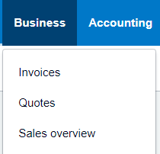

- Click Awaiting Payment

- This will bring up a list of invoices that have been generated and are awaiting payment.
- Sort the invoices by Date and tick the Unsent Only box and then click Search.


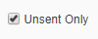
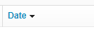

- Now check the invoices are dated with today’s date (or weekend dates if doing it on a Monday)
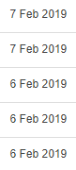

- On the right-hand side there is a column called Sent. Once an invoice has been sent to a customer it will show up sent in green. You will also be able to tell if a customer has viewed the invoice online. (Note it doesn’t always mean they haven’t seen it if it doesn’t say viewed)

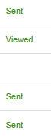

- Check the reference of each invoice – Monthly Reoccurring can be sent out straight away
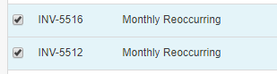

- Use the check boxes on the left hand side to check the invoices that need to be sent.

- Then click Email found at the top
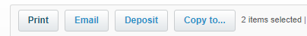

- Ensure the email template Says Sales Invoice: Basic
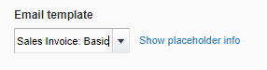

- Ensure PDF Attachment and Mark as sent are ticked
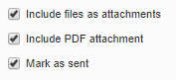

- Once you are happy click Send



- Adwords Invoices are slightly different. They need amending each month before being sent out.

- The reference will clearly show if it is an adwords invoice

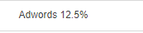

- Click on the company name to open the invoice

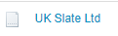

- The Invoice description will show the amount that should be put in the invoice.
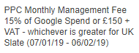

- The admin team will keep this spreadsheet: Ad Word Management Spreadsheet.xlsx up to date.

- The admin team find out what the google ad spend is for the month by www.adwords.google.com & please ask the adwords team what the Bing monthly cost is.

- Change the date range to what it should be and click apply.
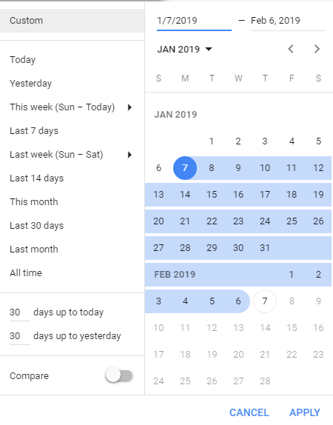

- Start typing the website name and click on the account. Take the amount from the cost/total: campaigns section and add it in column D on the spreadsheet and the invoice amount/management fee will show in column G.
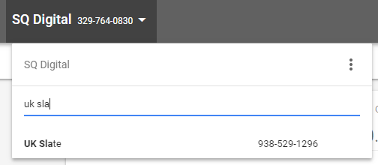

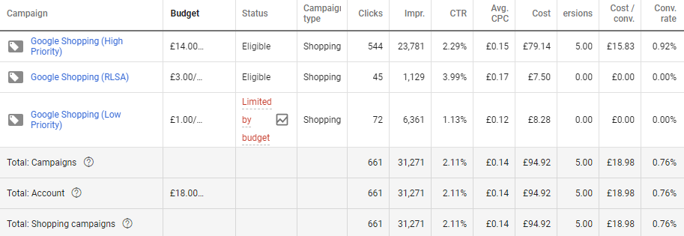

- If the management fee is more than minimum cost (£150) then edit the invoice by clicking invoice option and edit and then update the invoice amount with the new management fee.
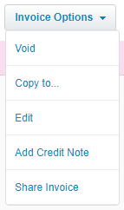

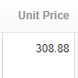

- Now update the invoice.

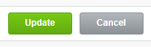

- This will bring up the finished invoice which you can send directly to the customer. (Complete steps 11 – 14)
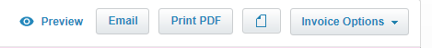

- Annual Hosting invoices need to be checked before sending out.

- Open the invoice and ensure that the invoice period is correct (It should be for the coming year)

- Annual Hosting invoices are generally raised 6 weeks in advance to ensure payment is received before the hosting automatically renews.

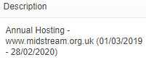

- If the invoice is not 6 weeks before the hosting expires, edit the repeating transaction template for next year and click save.

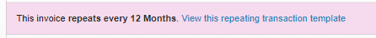

- Once the invoice has been updated with the correct period this can then be sent to the customer. But this time use the hosting renewal email template.
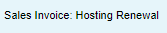

- Please repeat the same process for sending hosting invoices when sending out SSL invoices. Please use the SSL renewal email template.
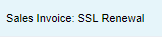

- S/O or GI these invoices do not need to be sent until we receive payment – this will be shown below!

Sending out paid invoices
This should be completed after the bank reconciliation – See SQ How to Do a Bank Reconciliation

- Log into Xero

- Click Business

- Click Invoices

- Click Paid

- Click the search button, tick the unsent only and then click search.
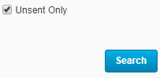
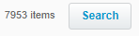

- S/O and GI invoices that have been paid off will be unsent in this list.
- You do not need to send credit notes from this screen so they can be left unsent.

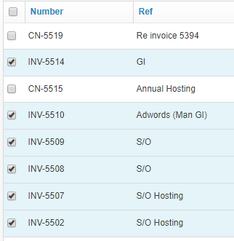

- Use the tick boxes to select all the invoices that need sending out.

- Click Email
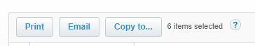

- Change the email template to Sales Invoice: Standing Order Paid

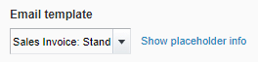

- Now you can send out the paid invoices.

